Statistics Lecture 5.3: A Study of Binomial Probability Distributions

Binomial Probability Distribution:
A probability distribution that only has two outcomes. (success or failure)

Rules:
- Must be a fixed number of trials.
- Trials must be independent. (The outcome of one trial does not affect the others)
- Each trial has only two outcomes. (success or failure)
- The probability of success remains the same in all trials.

Notation:
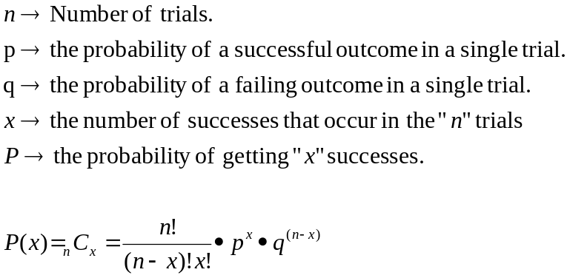

Example:
Flip a coin 1000 times. What is the probability of getting exactly 501 heads?
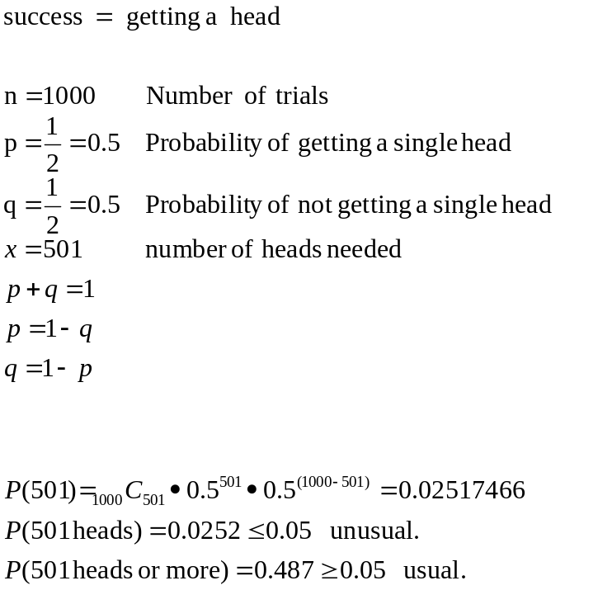
Weighted Dice
The probability of rolling a “4” is 30%.
The dice is rolled 10 times.
Find the Probability of rolling exactly 8 “4”s.
Success: rolling a “4”
Failure: rolling a “1”,“2”,“3”,“5”,“6”

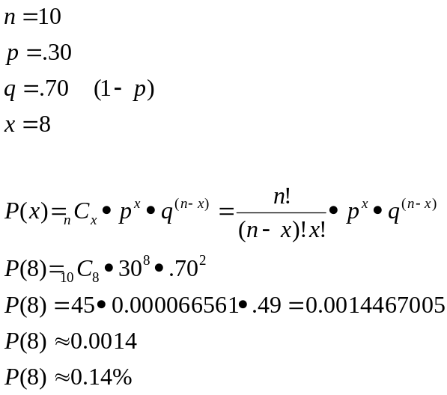

Weighted Dice (addition rule)
The probability of rolling a “4” is 30%.
The dice is rolled 10 times.
Find the Probability of rolling at most 8 “4”s.

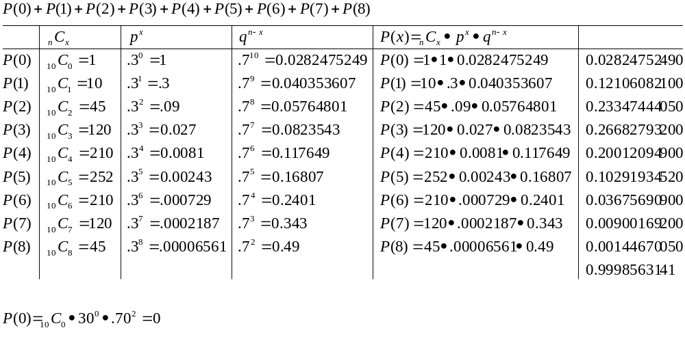
Cards: You draw 7 cards with replacement. You win the “game” if you get at least 5 hearts.

Success: drawing a heart
Failure: Not drawing a heart.

